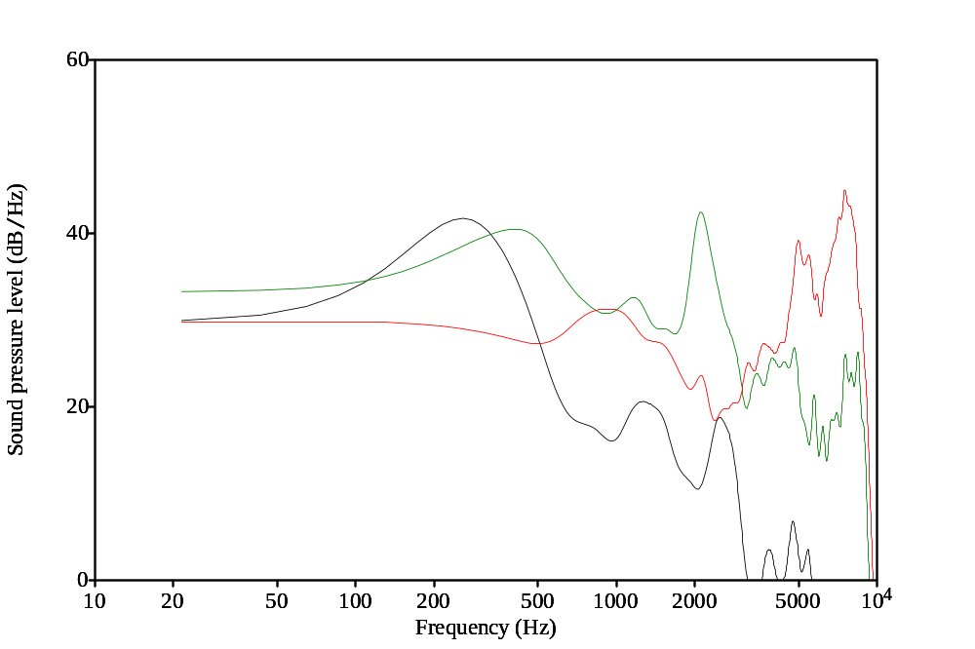

Fig. 1. Frequency spectrum for /m/ /g/ /t/ tokens smoothed

NB. SAJCD is black and white only so please change the colours in this graph so it looks like the one below, i.e. grey line and dotted line instead of green line and red line.

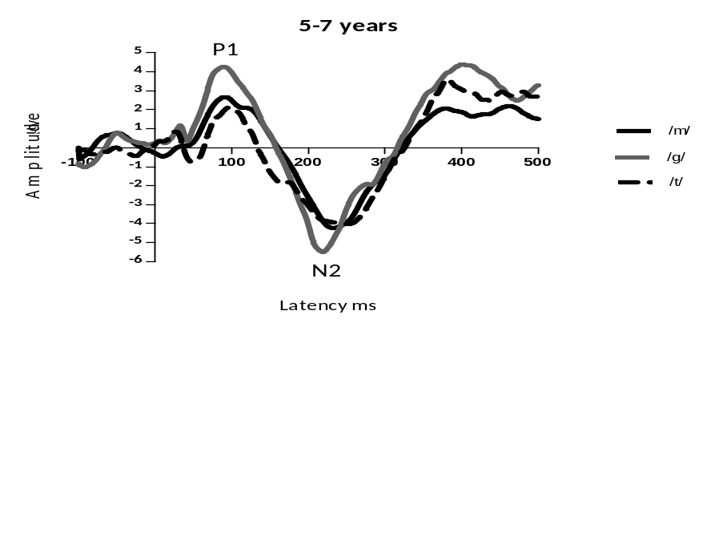
Fig. 2. Grand averaged CAEP waveforms in response to the three speech stimuli

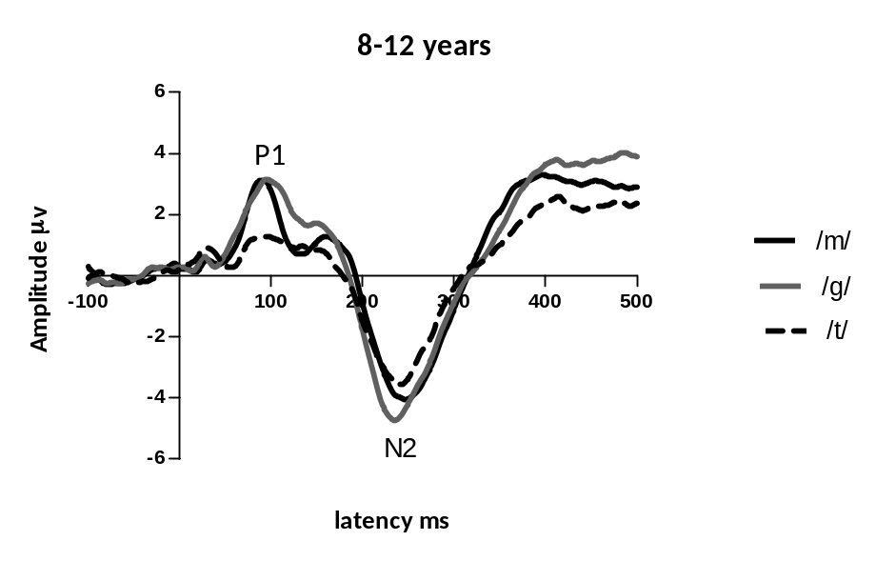
Fig. 3. The grand averaged CAEP waveforms in response to the three speech stimuli in the 8−12 years age group

