Appendix B. Response form for assessing speech processing and production in young children

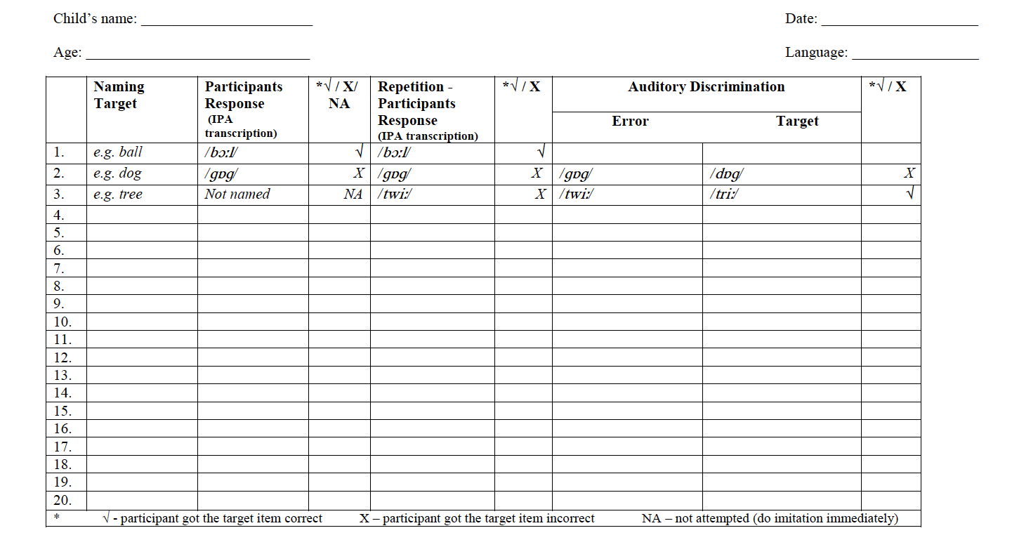

Appendix C. Analysis sheet for assessing speech processing and production in young children

