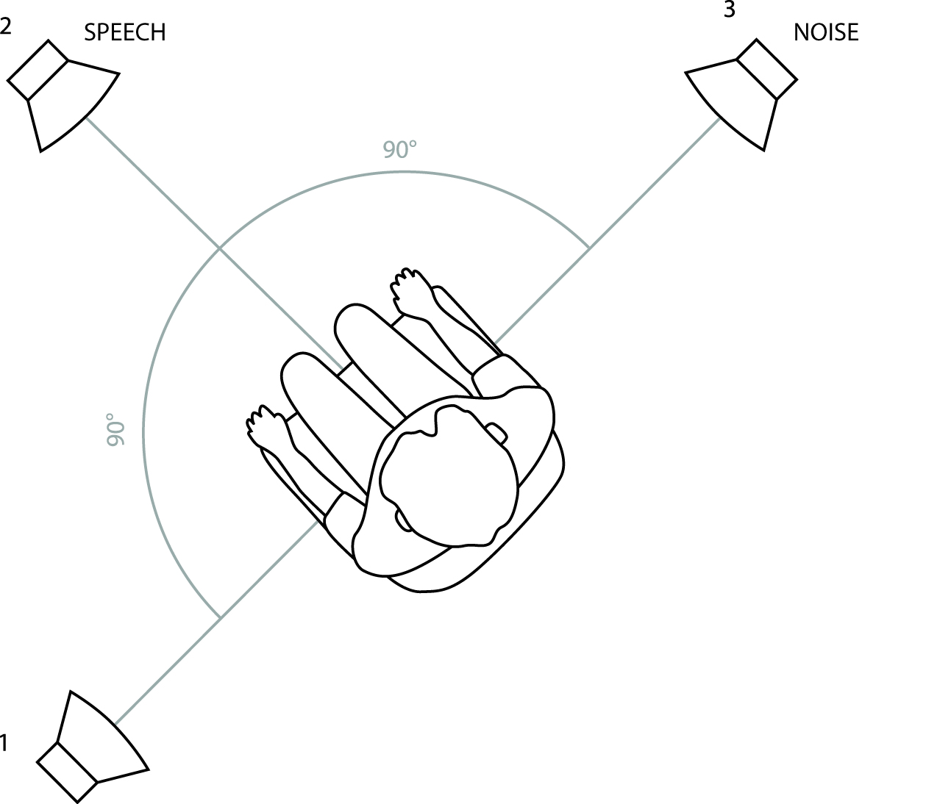

FIG 1. Test setup to determine speech-perception-in-noise: speech and noise spatially separated with noise directed to the right ear. Speech was presented from the front loudspeaker (numbered 2) and noise was presented from the loudspeaker on the participant’s right-hand side (numbered as 3).

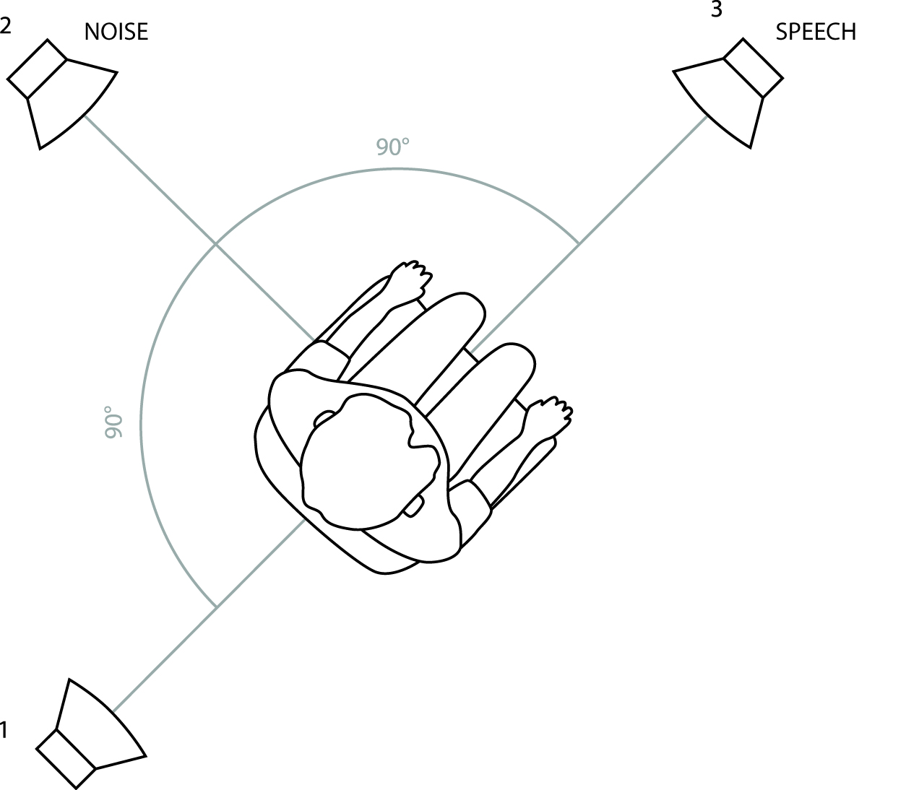

FIG 2: Test setup to determine speech-perception-in-noise: speech and noise spatially separated with noise directed to the left ear. Speech was presented from the front loudspeaker (numbered 3) and noise was presented from the loudspeaker on the participant’s left-hand side (numbered 2).

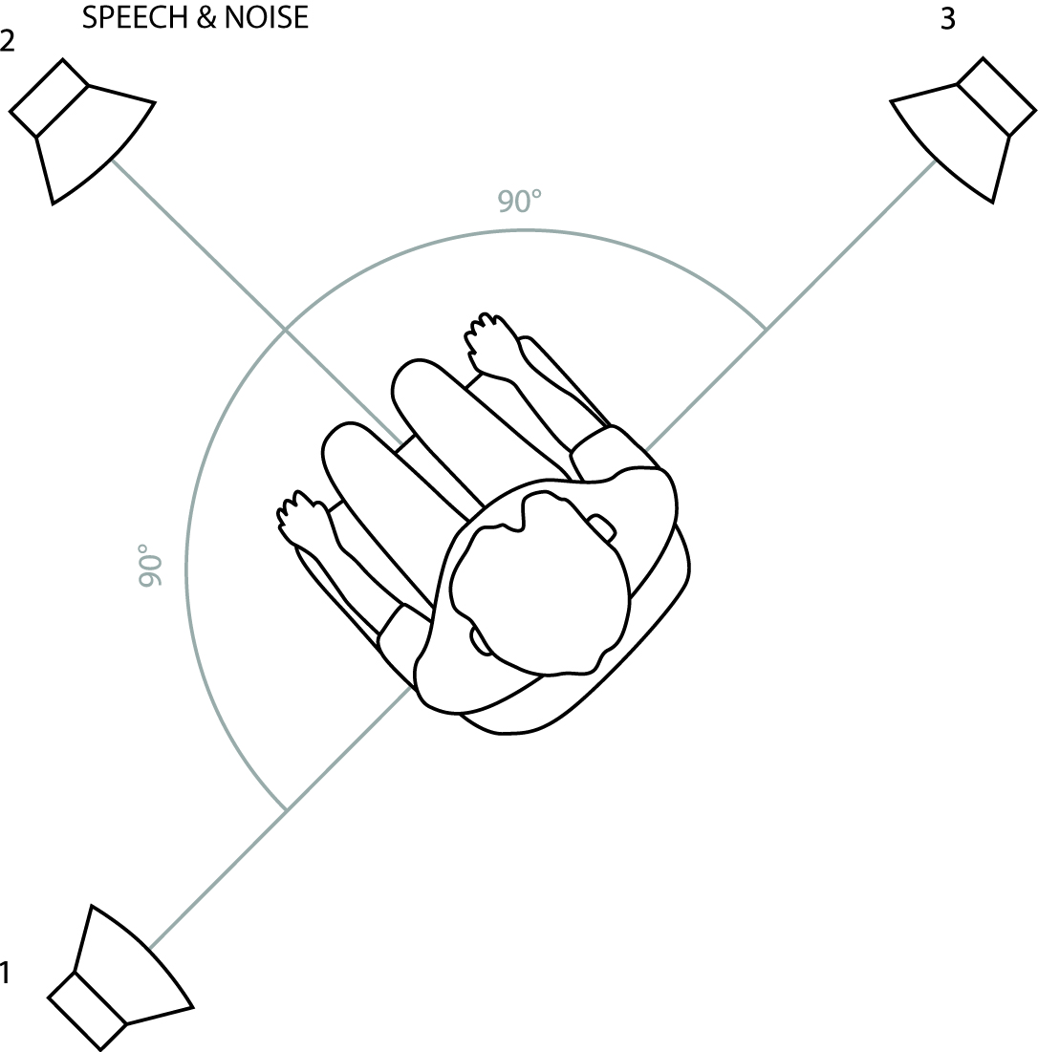

FIG 3. Test setup to determine speech-perception-in-noise abilities: speech and noise spatially coincident. Speech and noise were presented simultaneously from the loudspeaker directly in front of the participant (numbered 2).

